- calendar view - Normal view consists of Company name, time, initials of participants, indicator showing which interest stage the negotiation is, and the meeting count
- On hover there is no hover card anymore
- The Sync Calendar button now auto-syncs every 10 seconds and shows "Synced ✓" for 3 seconds after each sync completes, then reverts back to "Sync Calendar".
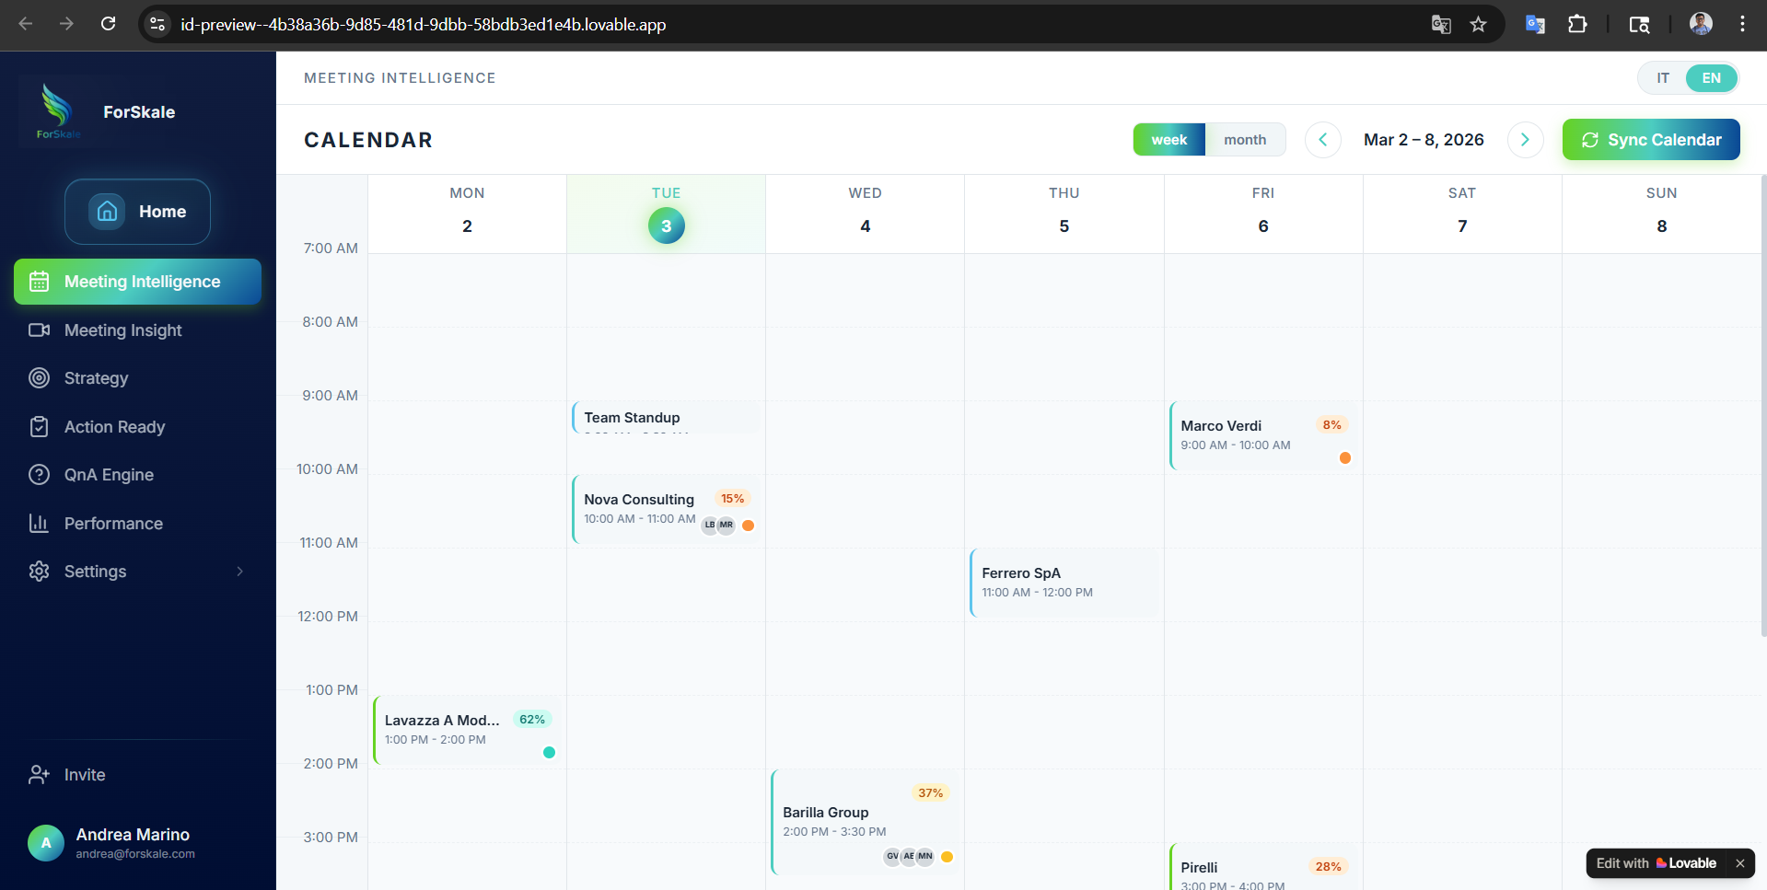

Interest % | Cognitive State | CRM Stage | UI Color | Psychology
10-20% | Attention | Lead/Prospect | Red/Orange | "They notice you exist"
20-30% | Curiosity | Qualified Lead | Orange | "They want to know more"
30-40% | Engagement | Discovery | Amber | "They're engaged"
40-50% | Problem Recognition | Discovery/Demo | Amber | "They see the problem"
50-60% | Trust | Demo | Teal | "They trust your solution"
60-70% | Evaluation | Proposal | Teal | "They're comparing options"
70-80% | Validation | Negotiation | Teal | "Validating fit & consensus"
80-90% | Hard Commitment | Closing/Won | Green | "Ready to commit"
90%+ | Decision | Closed Won | Green | "Decision made"
0% | Lost | Closed Lost | Red | "Deal lost"

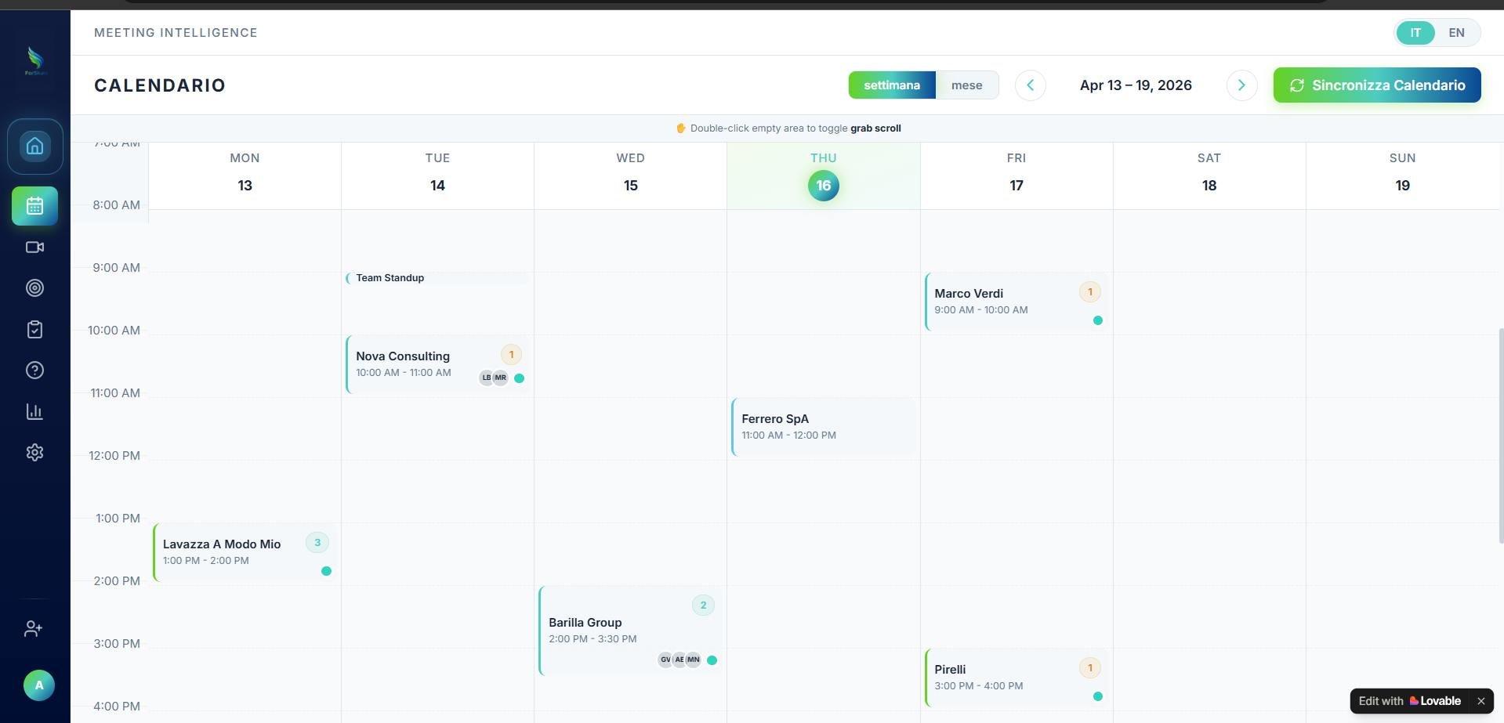

Visual Interface Analysis

Header Section
- Title: “CALENDARIO” (bold, uppercase)
- View Toggle: Two-state button with “settimana” (active, gradient green) and “mese” (inactive, muted)
- Date Navigation: Left/right chevrons surrounding “Apr 13 – 19, 2026”
- Sync Button: “Sincronizza Calendario” with refresh icon (green-to-blue gradient)
- Interaction Hint: Top banner stating “Double-click empty area to toggle grab scroll” with orange indicator dot

Calendar Grid Structure
- Time Gutter: Left column showing hourly slots (7:00 AM through 4:00 PM visible)
- Day Columns: Monday through Sunday headers with date numbers
- Today Highlight: Thursday 16 features a filled green gradient circle and subtle column background tint
- Grid Lines: Dashed horizontal separators between hour slots

Meeting Cards — Current Display Analysis

Visible Meetings This Week
Meeting | Day | Time | Maating Badge | Badge Color | Status Dot
Team Standup | Tue 14 | 9:00 AM (short) | None | N/A | None
Nova Consulting | Tue 14 | 10:00 AM – 11:00 AM | 1 | Amber | Teal
Lavazza A Modo Mio | Mon 13 | 1:00 PM – 2:00 PM | 3 | Teal | Teal
Ferrero SpA | Thu 16 | 11:00 AM – 12:00 PM | None visible | N/A | None
Barilla Group | Wed 15 | 2:00 PM – 3:30 PM | 2 | Teal | Teal
Marco Verdi | Fri 17 | 9:00 AM – 10:00 AM | 1 | Amber | Teal
Pirelli | Fri 17 | 3:00 PM – 4:00 PM | 1 | Amber | Teal

Meeting Card Components
Each external meeting card displays:
- Company Name (bold, primary text)
- Time Range (smaller text below name)
- Meeting Sequence Badge (top-right corner):
  - Amber styling for Meeting 1 (first ForSkale meeting)
  - Teal styling for Meeting 2+ (continuation meetings)
- Participant Avatars (bottom area, overlapping circles with initials)
- Status Dot (bottom-right, teal indicating active deal status)
- Left Border Color (indicates meeting type: discovery/renewal/internal)

Functional Requirements

Auto-Sync Behavior (New Logic)
The sync button implements automatic calendar synchronization:
Backend Endpoint:
POST /api/calendar/sync
Response: { success: boolean, newMeetingsCount: number }

Calendar Start Time Logic
The calendar must dynamically start 1 hour before the earliest meeting of the displayed week. Backend provides accurate start/end times; frontend calculates optimal display range.

Hover Behavior Changes
- Meeting cards: Simple hover styling only (no hover card tooltips)
- Calendar background: Hover anywhere shows tooltip with:
  - Cognitive state
  - Company name
  - Participant count
  - Date

Click Interactions
- Meeting card click: Opens Contact Card panel (full meeting intelligence)
- Empty area double-click: Toggles grab scroll mode
- View toggle: Switches between weekly/monthly layouts

Integration with Corrected Business Logic
Important: While meeting sequence numbers are displayed on calendar cards for user context, the underlying strategy mode determination uses interest percentage thresholds:
- Meeting badges show chronological count ( 1, 2, 3…)
- Strategy content is determined by interest level (≤10% = first interaction, >10% = deal context)
- These can diverge: A Meeting 1 with 45% interest uses continuation strategy content
Example:
- Nova Consulting shows “1” badge (first ForSkale meeting)
- But if interest > 10%, backend generates deal context strategy
- Visual display and content strategy operate independently

Implementation Priorities

Phase 1: Visual Accuracy
- Meeting sequence badges with correct amber/teal styling
- Status dots reflecting deal velocity
- Participant avatar overlays
- Today highlighting with gradient circle

Phase 2: Auto-Sync Functionality
- 10-second polling implementation
- “Synced ✓” confirmation display
- Error handling for sync failures

Phase 3: Dynamic Calendar Range
- Calculate earliest meeting time
- Adjust calendar start time accordingly
- Smooth scrolling to current time

Phase 4: Interaction Polish
- Hover tooltip system
- Grab scroll mode toggle
- Smooth transitions between views
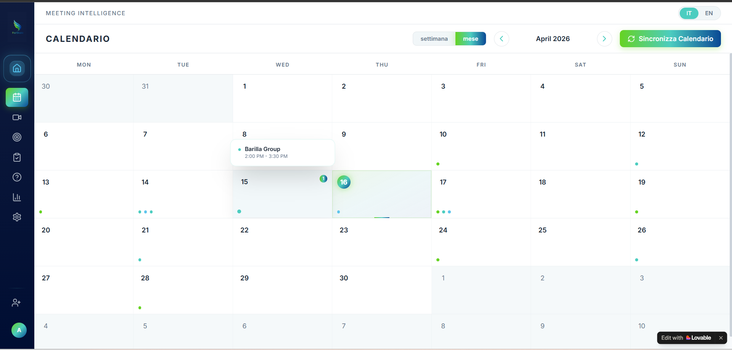

Visual Interface Analysis

Header Section
- Title: "CALENDARIO" (unchanged from weekly view)
- View Toggle: "mese" is active (green gradient styling), "settimana" is inactive (muted)
- Date Navigation: Displays "April 2026" (month-level label) with left/right chevrons for month-by-month navigation
- Sync Button: "Sincronizza Calendario" maintains the 10-second auto-sync behavior established in the weekly view

Calendar Grid Structure
- Layout: Standard 6×7 grid (42 total cells, Monday-first)
- Current Month Days: April 1–30 with standard white/card background
- Overflow Days: March 30–31 and May 1–10 displayed with muted styling to complete the grid
- Today Highlight: April 16 features a filled green gradient circle around the date number plus subtle column background tint

Selected Week Indication
The screenshot shows April 15–19 with a distinctive light teal background overlay, indicating the week range that was active when switching from weekly to monthly view. This provides visual continuity between view modes.

Meeting Representation System

Meeting Indicator Dots
Small colored dots at the bottom of day cells represent meeting density:
Dot Color | Meeting Type | Cognitive State Range | Example Days
Teal/Cyan | Discovery meetings | Trust, Evaluation stages | April 14, 17, 24
Green | Renewal meetings | Various stages | April 13, 20, 26
Amber | Internal meetings | N/A | April 21, 28
Dot Display Rules:
- dots shown all calls in a day
- Dot size: 6×6px, fully rounded
- Positioning: Horizontal row at bottom of cell with 4px gaps

Inline Event Preview
When space permits and a meeting is significant, one event renders as a compact inline card:

Meeting Sequence Badges
Small numeric badges appear in the top-right corner of cells containing meetings:
- "1" badge visible on April 15 (amber styling for first meetings)
- "2", "3" badges use teal styling for continuation meetings
- Size: 16×16px rounded circle
- Purpose: Shows meeting sequence for context (display only, not strategy determinant)

Interaction Behaviors

View Toggle Synchronization
- Weekly → Monthly: Preserves active week as highlighted range in monthly view
- Monthly → Weekly: Returns to the week containing the selected/clicked date
- State preservation: Selected week highlighting maintains visual continuity

Hover Interactions
Hovering over a day cell with meetings displays a floating tooltip:
Tooltip Content:
- Multiple meetings: Stacked chronologically
- Per meeting: Colored dot + company name + time range + cognitive state
- Styling: White background, soft shadow, rounded corners
- Positioning: Above cursor, auto-adjusting for screen edges

Click Interactions
- Day cell click: Opens Day Detail Panel (slide-in from right) listing all meetings for that day
- Inline event click: Directly opens Contact Card with full Meeting Intelligence
- Meeting in tooltip click: Opens Contact Card for that specific meeting
- Navigation chevrons: Fetch new month data and re-render grid

Auto-Sync Integration
Maintains the 10-second polling established in weekly view:
- Backend call: POST /api/calendar/sync every 10 seconds
- UI feedback: "Synced ✓" for 3 seconds after successful sync
- Error handling: Graceful degradation if sync fails
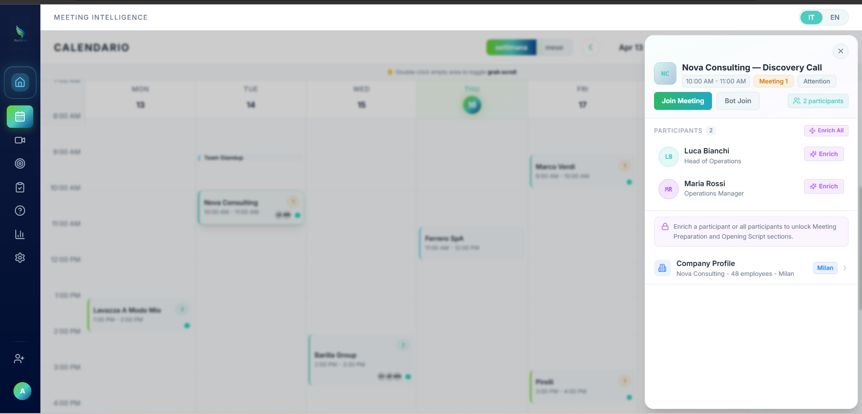

Gated Content Logic System

Locked State Conditions
The strategy content remains locked when:
const isLocked = meeting.participants.every(p => !p.isEnriched);

Unlocked State Trigger
Prospect intelligence Opens
const isUnlocked = meeting.participants.some(p => p.isEnriched);

User Flow to Unlock
- User clicks individual “Enrich” → enrichment modal → single participant enriched → content unlocks
- User clicks “Enrich All” → bulk enrichment → all participants enriched → content unlocks
- System fetches full strategy content: GET /api/meetings/:id/strategy
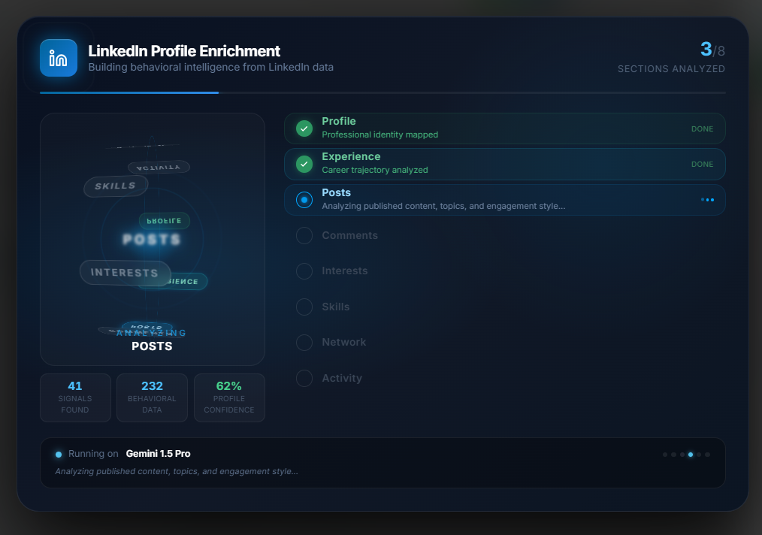
New enrichment modal
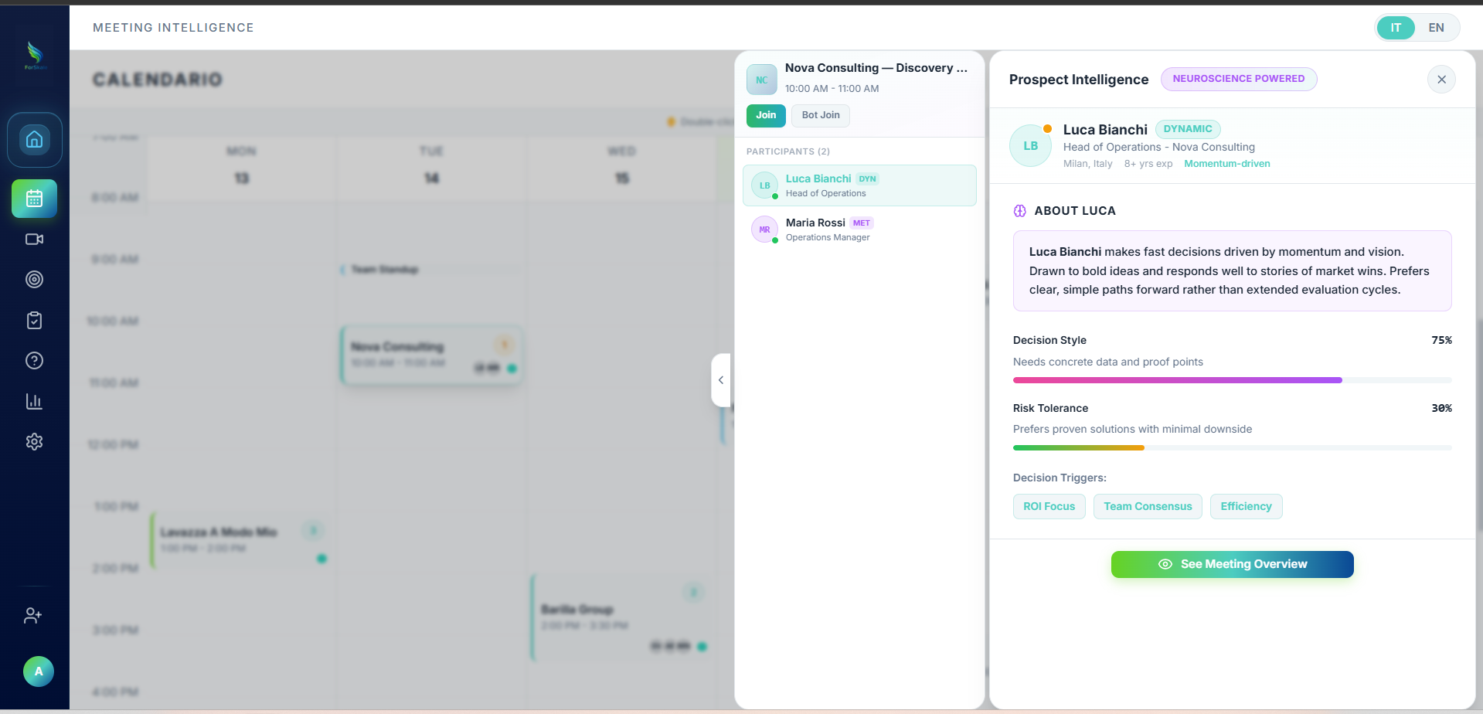

Profile Identity Block
[LB] Luca Bianchi [DYNAMIC]
Head of Operations — Nova Consulting
Milan, Italy · 8+ yrs exp · Momentum-driven

Data Sources:
- Name, role, company: LinkedIn enrichment
- DYNAMIC badge: Result of assignArchetype() algorithm
- Location, tenure: Scraped profile data
- "Momentum-driven": Archetype behavioral descriptor

Mappa degli Archetipi / Archetype Mapping
Logica Interna / Internal Logic | Etichetta Inglese / English Label | Etichetta Italiana / Italian Label
Fast, high-risk, momentum-driven | Dynamic | Dinamico
Precise, slow, detail-obsessed | Methodical | Metodico
Strongly data/ROI-driven | Analytical | Analitico
Needs group alignment & buy-in | Diplomatic | Diplomatico
Visionary, innovation-led | Innovator | Innovatore
Control-, security-, stability-oriented | Prudent | Prudente
Highly skeptical, trust-sensitive | Scrupulous | Scrupoloso
Upside/ROI + willing to move fast | Pragmatic | Pragmatico

CONCEPT OF DYNAMIC STYLE AND RISK TOLERANCE:

Behavioral Score Bars — Alternative Use Cases & Logic

Core Score Definitions
Score | English | Italian | What It Measures | UI Element
Decision Style | Decision Style | Stile Decisionale | How much proof/data needed before deciding | Horizontal progress bar with percentage
Risk Tolerance | Risk Tolerance | Tolleranza al Rischio | Comfort level with uncertainty and change | Horizontal progress bar with percentage

UI/UX Element Standards
Element | English | Italian | Visual Behavior | Color Logic
Score Bar | Progress Bar | Barra di Progresso | Left-to-right fill, 200px width | Gradient based on score range
Percentage Label | Score Display | Visualizzazione Punteggio | Right-aligned number (e.g., "75%") | Same color as bar
Descriptor Text | Behavior Label | Etichetta Comportamento | Single line below bar, plain language | Muted text color
Icon Badge | Score Icon | Icona Punteggio | Small circular badge next to bar | Colored dot matching bar

Decision Style Score — Use Cases
Score Range | English Label | Italian Label | Sales Logic | UI Element
0–30% | Intuitive | Intuitivo | Lead with vision, skip heavy data | Green badge: "Story-driven" / "Guidato dalle storie"
31–60% | Balanced | Equilibrato | Mix emotion with some proof points | Amber badge: "Balanced approach" / "Approccio equilibrato"
61–100% | Evidence-Based | Basato su Prove | Must have data, case studies, ROI | Red badge: "Proof required" / "Prove richieste"

Decision Style Applications
Use Case | English | Italian | Logic | UI Element
Demo Depth | Presentation Depth | Profondità Presentazione | High score = detailed slides, Low score = high-level overview | Slider preset: "Detail Level" / "Livello Dettaglio"
Case Study Selection | Proof Type | Tipo di Prova | High score = ROI data, Low score = success stories | Chip suggestions: "Recommended Evidence" / "Prove Consigliate"
Meeting Structure | Talk Track | Scaletta Conversazione | High score = structured agenda, Low score = flexible flow | Toggle: "Structured" vs "Flexible" / "Strutturato" vs "Flessibile"

Risk Tolerance Score — Use Cases
Score Range | English Label | Italian Label | Sales Logic | UI Element
0–30% | Risk Averse | Avverso al Rischio | Emphasize safety, guarantees, pilot programs | Red badge: "Safety first" / "Sicurezza prima"
31–60% | Cautious | Cauto | Proven solutions with clear ROI boundaries | Amber badge: "Proven path" / "Percorso provato"
61–100% | Risk Embracer | Amante del Rischio | Bold proposals, fast implementation, innovation focus | Green badge: "Bold moves" / "Mosse audaci"

Risk Tolerance Applications
Use Case | English | Italian | Logic | UI Element
Deal Structure | Proposal Type | Tipo Proposta | Low score = pilot phase, High score = full implementation | Banner: "Suggested Deal Shape" / "Forma Accordo Suggerita"
Timeline Expectation | Expected Pace | Velocità Attesa | Low score = slower process, High score = fast decision | Progress indicator: "Deal Velocity" / "Velocità Accordo"
Reassurance Focus | Safety Emphasis | Enfasi Sicurezza | Low score = highlight guarantees, High score = minimize safety talk | Alert box: "Reassurance Needed" / "Rassicurazioni Necessarie"

Combined Score Intelligence (Most Valuable)
Decision Style | Risk Tolerance | Profile Type | English | Italian | Sales Approach
High + Low | Analytical Conservative | Analista Conservatore | Conservatore Analitico | Lead with detailed ROI + safety guarantees
High + High | Data-Driven Innovator | Innovatore Guidato dai Dati | Innovatore Basato sui Dati | Show proof fast, then accelerate boldly
Low + High | Visionary Risk-Taker | Visionario Coraggioso | Visionario che Rischia | Big picture first, skip technical details
Low + Low | Relationship Builder | Costruttore di Relazioni | Costruttore di Rapporti | Slow trust-building, no pressure tactics
Mid + Mid | Pragmatic Buyer | Acquirente Pragmatico | Compratore Pragmatico | Balanced approach, flexible strategy

Practical Application Areas
Application | English | Italian | Trigger Logic | UI Location
Content Recommendations | Suggested Materials | Materiali Suggeriti | Auto-select attachments based on scores | Contact Card bottom: attachment chips
Objection Prediction | Likely Pushback | Obiezioni Probabili | Predict specific objections from score combination | Strategy Panel: warning alerts
Meeting Pace Setting | Conversation Speed | Velocità Conversazione | Set recommended meeting tempo | Profile header: pace indicator
Follow-up Strategy | Next Step Type | Tipo Prossimo Passo | Suggest appropriate follow-up based on scores | Action bar: recommended next action
Team Assignment | Rep Matching | Abbinamento Venditore | Match prospect personality with sales rep style | Internal CRM: rep recommendation

Score Range Color Coding
Score Range | Color | English Meaning | Italian Meaning | Visual Treatment
0–30% | Red/Pink | Needs Special Approach | Richiede Approccio Speciale | Solid color fill
31–60% | Amber/Orange | Standard Process | Processo Standard | Gradient fill
61–100% | Green/Teal | Accelerated Track | Percorso Accelerato | Solid color fill
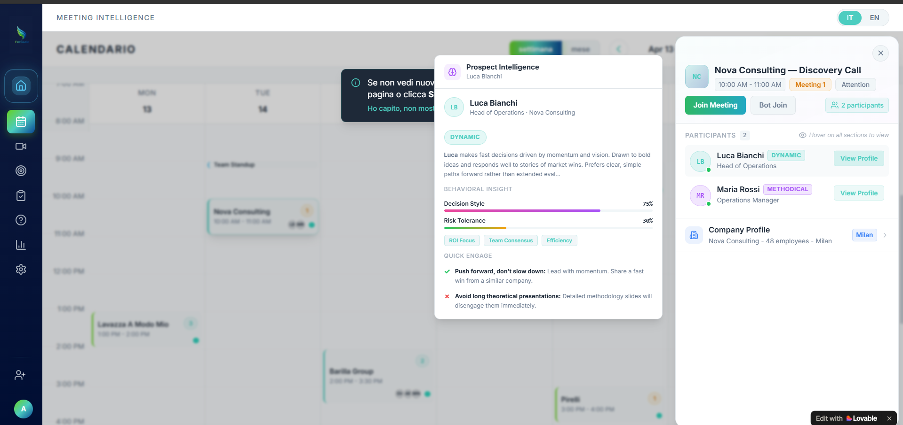
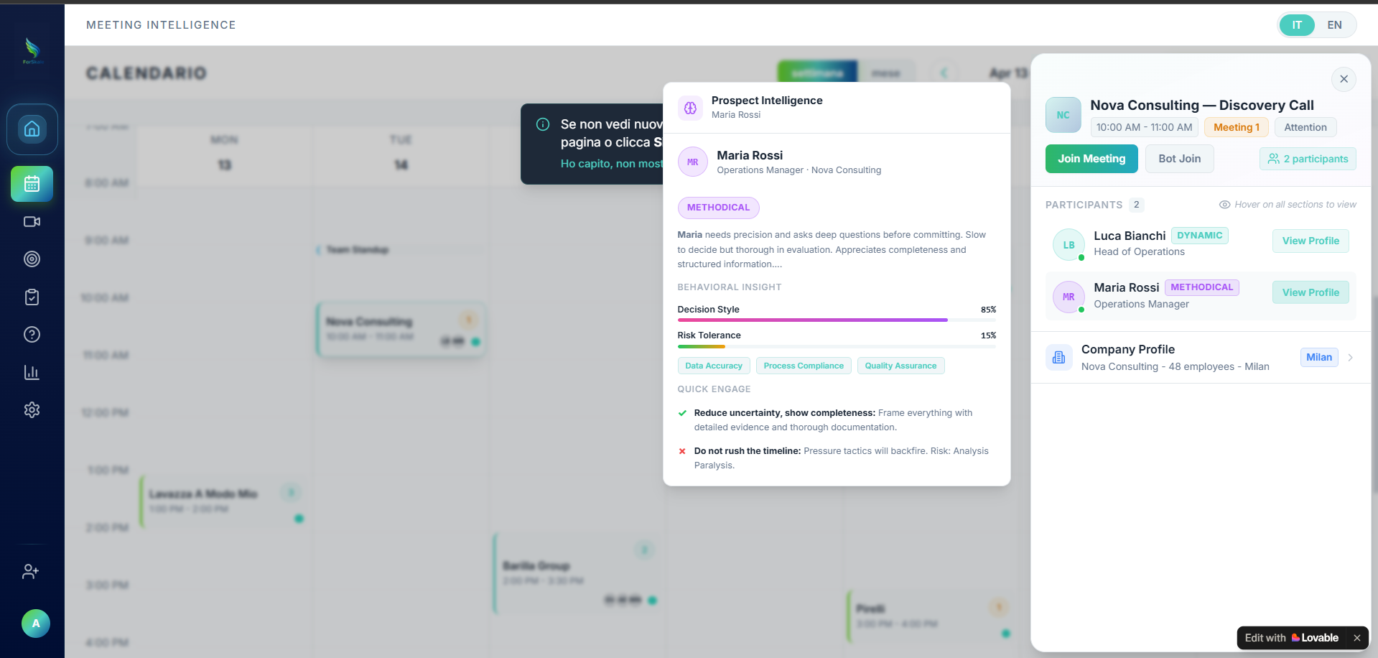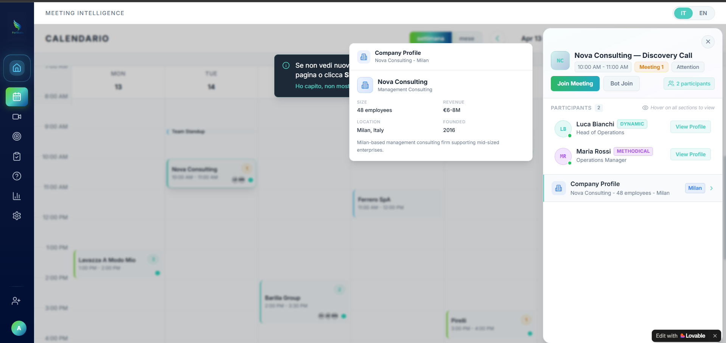

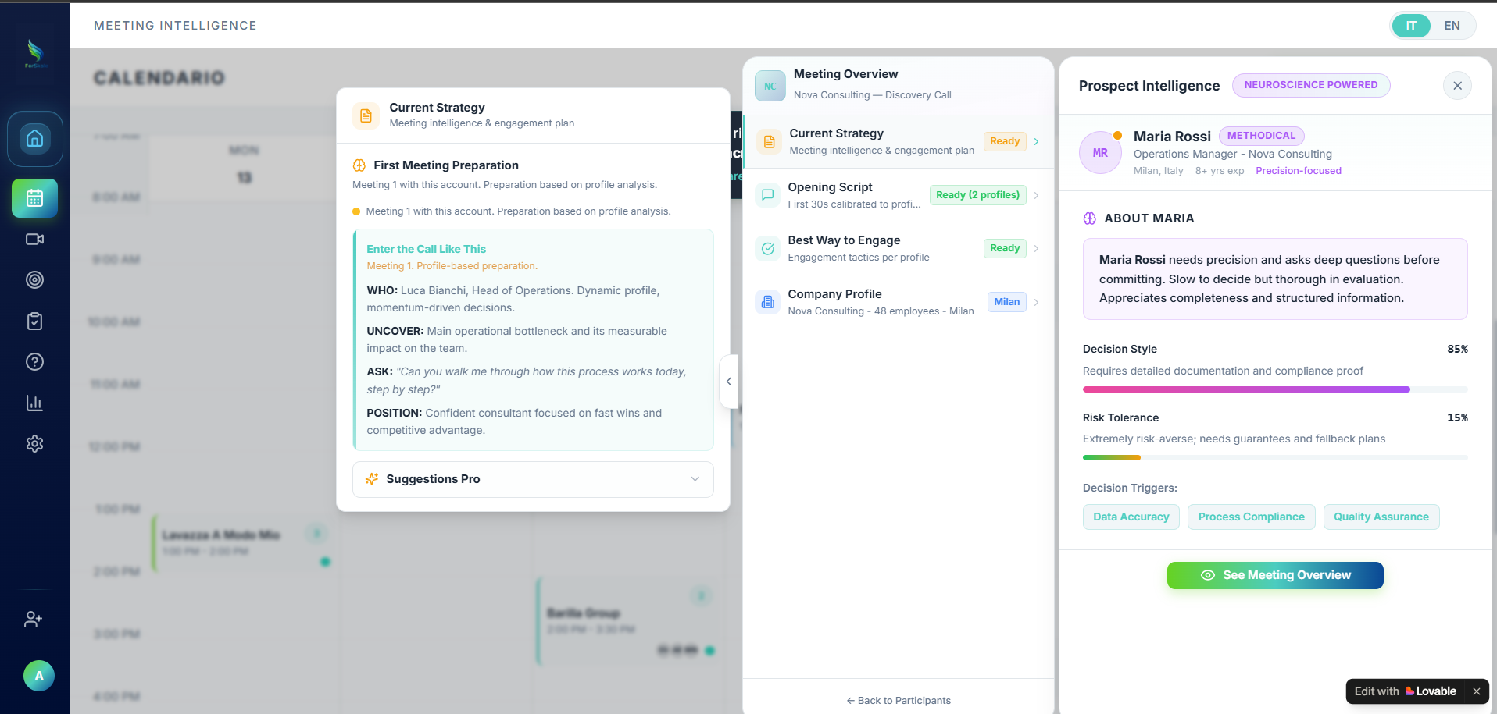

Current Strategy — Core Concept & Logic Summary
Current Strategy / Strategia Attuale
A dynamic, AI-generated meeting playbook that transforms behavioral data (archetype + engagement history) into specific, actionable guidance for the next 30-60 minutes of conversation.
The "Two-Mode Brain":
- First Interaction / Prima Interazione (Interest ≤10%): Profile-based predictions
- Deal Context / Contesto Accordo (Interest >10%): Evidence-based continuation

Core Logic & Mode Determination
Trigger | English Mode | Italian Mode | Data Source | Content Type | UI Element
Interest ≤10% | First Meeting Preparation | Preparazione Prima Riunione | Archetype + Role + Industry | Predictive/Hypothetical | Amber banner + dot
Interest >10% | Deal Continuation Strategy | Strategia di Continuazione | Previous transcripts + Evidence | Continuation/Reference-based | Teal/Blue/Red based on velocity

Critical Rule: Meeting sequence badges (M1, M2, M3) are display only. Strategy mode is determined by hidden interest threshold, not chronological count.

Enter the Call Card (Always Visible, Never Collapses)
Row | English | Italian | Content Logic | UI Element
WHO | Who | Chi | Name + Role + Archetype + behavioral note | Bold label + description
UNCOVER | Uncover | Scoprire | Primary discovery goal for this meeting | Bold label + objective
ASK | Ask | Chiedere | Single most important question (in quotes) | Bold label + italic quoted text
POSITION | Position | Posizionare | Value framing for this specific archetype | Bold label + positioning statement

Suggestions Pro Card (Collapsible)
Component | English | Italian | Rules | UI Treatment
Proposition | Proposition | Proposizione | Strategic context, max 120 chars | Muted label + plain text
Solution | Solution | Soluzione | Concrete action, present tense | Bold text + teal left border
Velocity Alert | Alert/Validate | Allerta/Validare | Only for Stalled/Fast deals | Red/Blue border section

Use Cases & Applications
Scenario | English | Italian | Internal Logic | Strategy Output
Cold First Meeting | Cold First Meeting | Primo Incontro Freddo | Meeting 1 + Interest ≤10% | "They are Methodical. Ask about step-by-step process. Position as structured consultant."
Warm Inbound | Warm Inbound | Lead Caldo | Meeting 1 + Interest >10% | "Skip basic discovery. They researched you. Ask what outcome they need today."
Normal Follow-up | Normal Follow-up | Follow-up Normale | Meeting 2+ + Normal velocity | "Last time they mentioned [X]. Follow up on that. Build on [Y] which resonated."
Stalled Deal | Stalled Deal | Accordo Bloccato | Meeting 4+ + Low progression | "Warning: 4 meetings without progress. Stop features. Ask direct qualifying question."
Fast Deal | Fast Deal | Accordo Veloce | High interest + Few meetings | "Reached Trust faster than typical. Validate signals before accelerating."

Behavioral Score Integration

Participant Switching Logic (Right Panel)
Profile | Archetype | Decision Style | Risk Tolerance | Sales Approach
Luca Bianchi | DYNAMIC | 75% | 38% | Lead with vision, momentum-based
Maria Rossi | METHODICAL | 85% | 15% | Detailed documentation, structured proof

Combined Score Intelligence
Decision Style | Risk Tolerance | Profile Type | English | Italian | Strategy Implication
High + Low | Conservative Analyst | Analista Conservatore | Conservatore Analitico | Detailed ROI + safety guarantees
High + High | Data-Driven Innovator | Innovatore Basato sui Dati | Innovatore Guidato dai Dati | Fast proof + bold acceleration
Low + High | Visionary Risk-Taker | Visionario Coraggioso | Visionario che Rischia | Big picture, skip technical details
Low + Low | Relationship Builder | Costruttore Relazioni | Costruttore di Rapporti | Slow trust-building, no pressure

Navigation Menu Logic (Middle Panel)
Menu Item | English | Italian | Status Logic | Badge Color
Current Strategy | Current Strategy | Strategia Attuale | Always available post-enrichment | Green "Ready"
Opening Script | Opening Script | Script Apertura | Unlocked when participants enriched | Green "Ready (2 profiles)"
Best Way to Engage | Best Way to Engage | Miglior Modo Coinvolgere | Generated from archetype data | Green "Ready"
Company Profile | Company Profile | Profilo Aziendale | Company data available | Neutral location pill

Content Generation Rules

Validation Standards
Rule | English | Italian | Application
Character Limit | 120 chars max | 120 caratteri max | Every text field
Bullet Count | 1-2 bullets per section | 1-2 punti per sezione | All strategy sections
Language Rules | No emojis, no em-dashes | Niente emoji, niente trattini | Content validation
Tone | Second person present tense | Seconda persona presente | "Ask...", "Position..."

Mode-Specific Content
Mode | Content Focus | English Example | Italian Logic
First Interaction | Archetype predictions | "Methodical buyers need structured timelines" | Previsioni basate su archetipi
Deal Context | Evidence references | "Last time they said [quote]. Build on that." | Riferimenti a prove precedenti
Stalled | Intervention tactics | "Change approach. Ask direct qualifying question." | Tattiche di intervento
Fast | Signal validation | "Moving fast. Validate authority before committing." | Validazione dei segnali

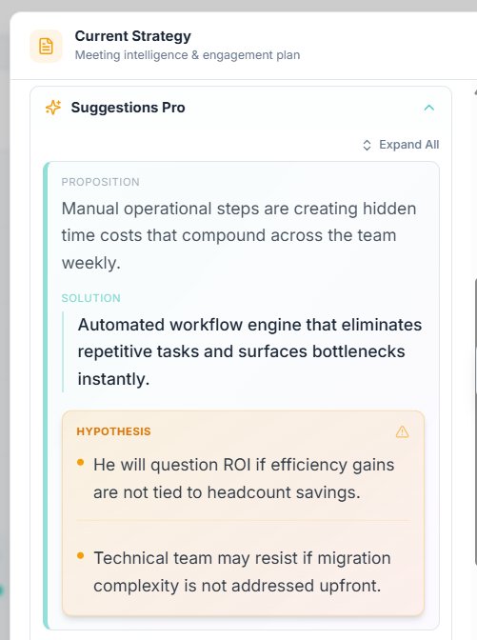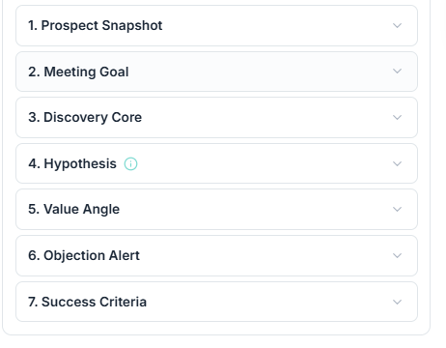Suggestions Pro — Complete Logic & Implementation Guide

Core Definition & Purpose
English: Premium AI micro-coach that transforms complex behavioral data into specific, expert-level tactical advice for the next 30-60 minutes of conversation.
Philosophy: Make sales reps feel like professionals by providing insider guidance that sounds premium and creates psychological motivation to act.

Three-Part Content Structure
Component | English | Italian | Purpose | Rules | UI Element
Proposition | Proposition | Proposizione | Explains WHY this situation requires a specific approach | Max 120 chars, expert observation tone | Plain text with muted label "PROPOSITION:"
Solution | Solution | Soluzione | 1-2 concrete actions to take immediately | Max 120 chars, second person present tense | Bold text with teal left border, label "SOLUTION:"
Hypothesis | Hypothesis | Ipotesi | 1-2 behavioral predictions for this meeting | Max 120 chars, 1-2 bullets only | Amber background box with warning triangle icon

Generation Logic Priority System
The system follows a strict hierarchy to determine content:

Priority 1: Deal Velocity Override (Highest)
Copy
if (dealVelocity === "STALLED" || dealVelocity === "FAST") {
return generateVelocitySpecificContent(dealVelocity, meetingSequence);
}

Velocity State | Section Added | English Label | Italian Label | Content Focus | UI Treatment
STALLED | Third section | ALERT | ALLERTA | Intervention tactics | Red left border
FAST | Third section | VALIDATE | VALIDA | Signal validation | Blue left border
NORMAL | No addition | — | — | Standard two-part only | Standard styling

Priority 2: Archetype-Specific Content
Copy
if (archetype && hasArchetypeContent(cognitiveState, archetype)) {
return getArchetypeSpecificContent(cognitiveState, archetype);
}

Priority 3: Cognitive State Fallback
Copy
return getCognitiveStateContent(cognitiveState);

Velocity-Based Content Examples

STALLED Deals (Multiple meetings, low progression)
- Proposition: "Four meetings without progression means your value is not landing or the problem is not real."
- Solution: "Stop presenting features. Ask directly: 'Is fixing this a priority for you this quarter?'"
- Alert: "Multiple meetings without progression. Ask directly: Is solving this a real priority this quarter?"

FAST Deals (High interest, few meetings)
- Proposition: "Reaching Trust in the first meeting is rare. Confirm this signal before accelerating the timeline."
- Solution: "Ask what specific outcome they need to see today to move forward with confidence."
- Validate: "Unusually fast progression. Confirm their urgency and decision authority before accelerating."

Content by Cognitive State
Cognitive State | English | Italian | Proposition Example | Solution Example
Attention (10-20%) | Attention | Attenzione | "They noticed you exist but have no reason to engage further yet." | "Open with one specific observation about their business. Ask one question that makes them think."
Curiosity (20-30%) | Curiosity | Curiosità | "They want to know more but have not connected your solution to their problem." | "Share one relevant case study in under 60 seconds. Then ask what resonated most."
Engagement (30-40%) | Engagement | Coinvolgimento | "They are actively exploring and will compare you to alternatives this week." | "Anchor one specific differentiator early. Repeat it naturally twice during the call."
Problem Recognition (40-50%) | Problem Recognition | Riconoscimento Problema | "They have identified a problem and are starting to believe it needs solving." | "Quantify the problem with their numbers. Ask what this costs them monthly."

Content by Archetype
Archetype | English | Italian | Proposition Example | Solution Example
Methodical | Methodical | Metodico | "Methodical buyers need to understand implementation timeline before committing." | "Proactively share a three-step onboarding plan before they ask about setup effort."
Dynamic | Dynamic | Dinamico | "Dynamic profiles lose focus during deep technical architecture explanations." | "Keep technical overview under two minutes. Pivot immediately to time saved."
Scrupulous | Scrupulous | Scrupoloso | "Scrupulous buyers are highly skeptical of generic marketing claims and ROI calculators." | "Reference a specific competitor they know. Share exact metrics you improved for them."
Analytical | Analytical | Analitico | "Analytical buyers require concrete ROI data before making any commitment decisions." | "Lead with quantified business case. Prepare three similar customer ROI examples."

Content Validation Rules (Non-Negotiable)
Rule | English | Italian | Implementation
Character Limits | 120 chars max per part | 120 caratteri max per parte | if (content.length > 120) throw ValidationError
No Emojis | No emojis anywhere | Niente emoji | const emojiRegex = /[\u{1F600}-\u{1F64F}]/gu
No Em-Dashes | No em-dashes | Niente trattini lunghi | if (content.includes('—')) replace with ':'
Action Language | Second person present tense | Seconda persona presente | "Ask...", "Share...", "Prepare..."
Bullet Count | 1-2 hypothesis bullets only | 1-2 punti ipotesi solo | `if (hypothesis.length === 0

Meeting Mode Integration
Strategy Mode | English | Italian | Hypothesis Source | Content Style
First Interaction (Interest ≤10%) | First Meeting Preparation | Preparazione Prima Riunione | Archetype predictions only | Template-based, hypothetical
Deal Context (Interest >10%) | Deal Continuation Strategy | Strategia Continuazione | Previous meeting transcript evidence | Evidence-based, referential
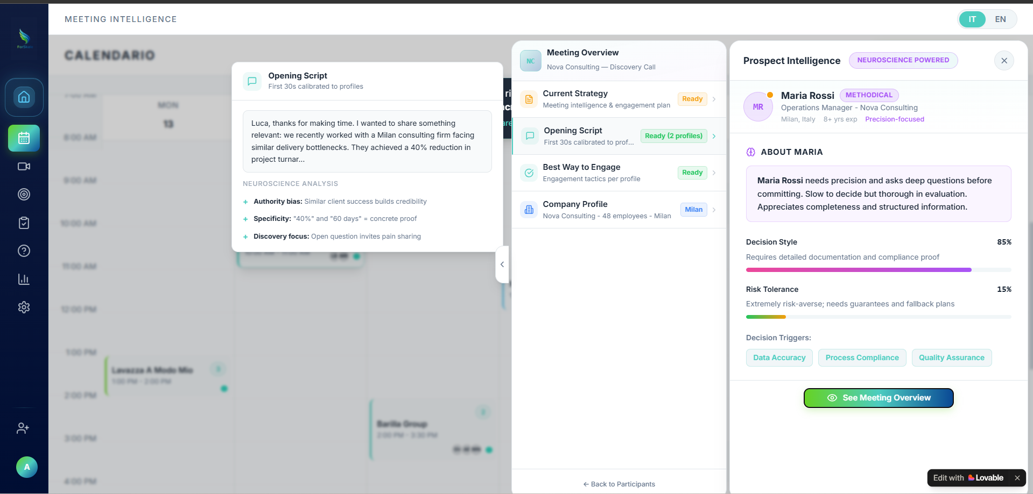
the opening script part should be on the basis of cognitive profile and previous meeting interactions, write in very short, use-cases basis or LLM prompt basis, whichever is simpler to generate this specific outout
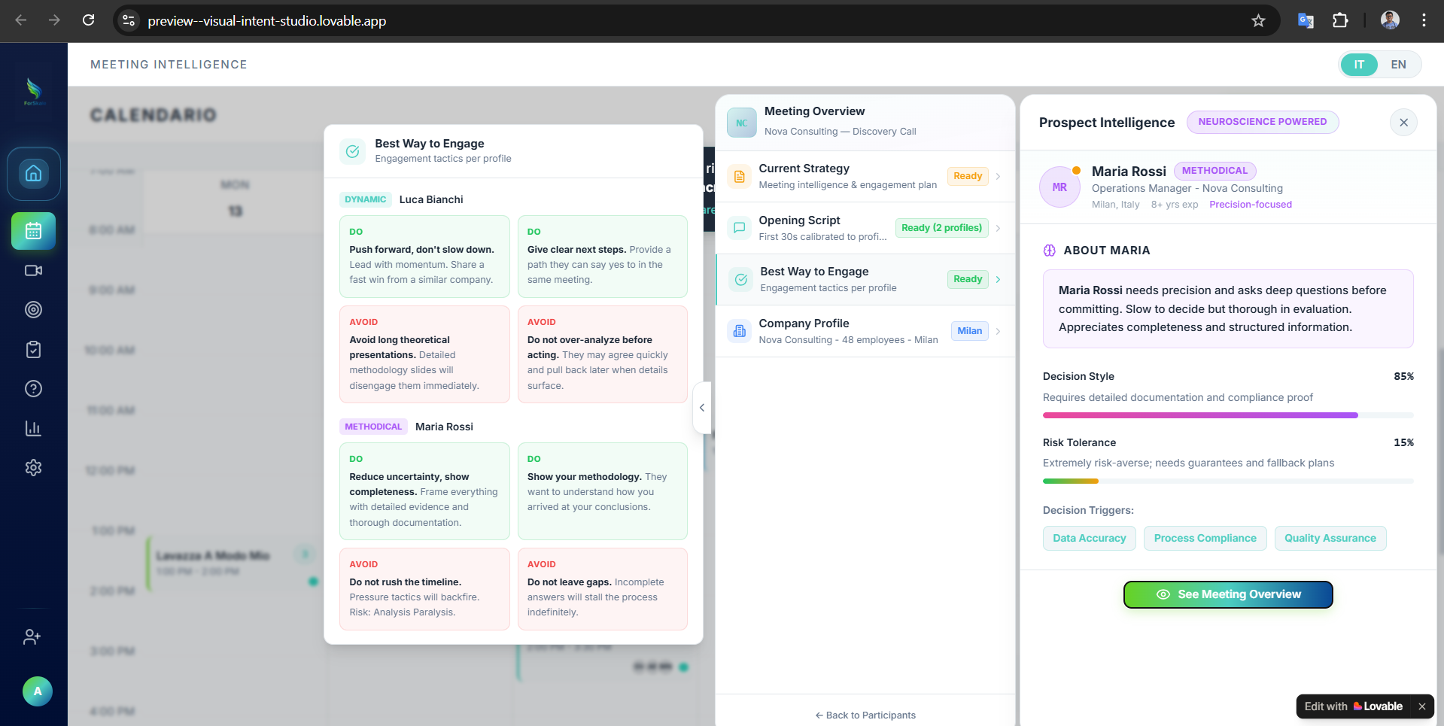
Same with best way to engage

